**Number Grid Map and Disk Transport**

**Alicia ananda / X IPS 1 / 01**

1. Playground Number Grid Map

**Hasil :**

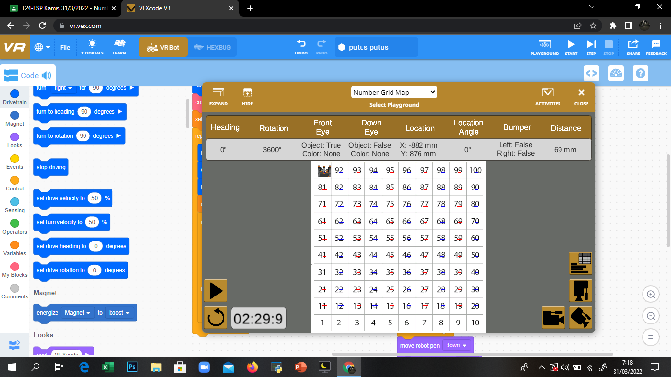

**Code :**

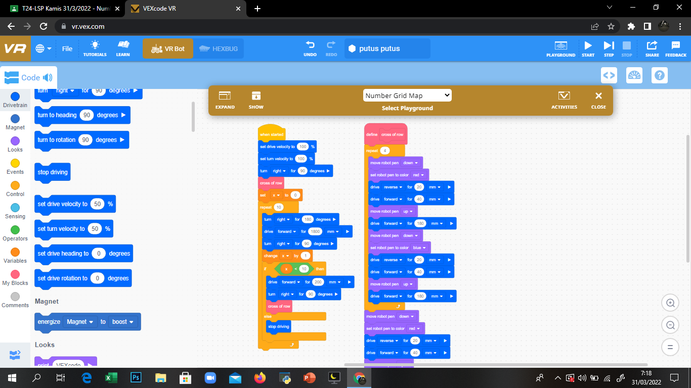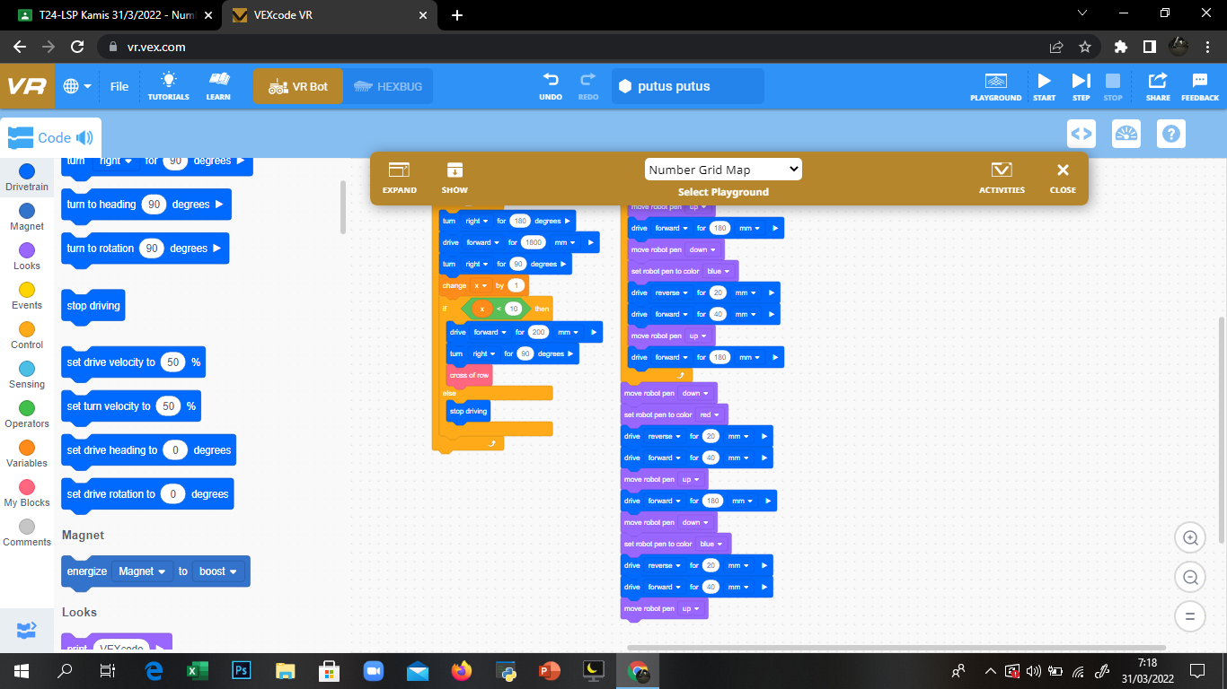

1. Playground Disk Transport

Hasil :

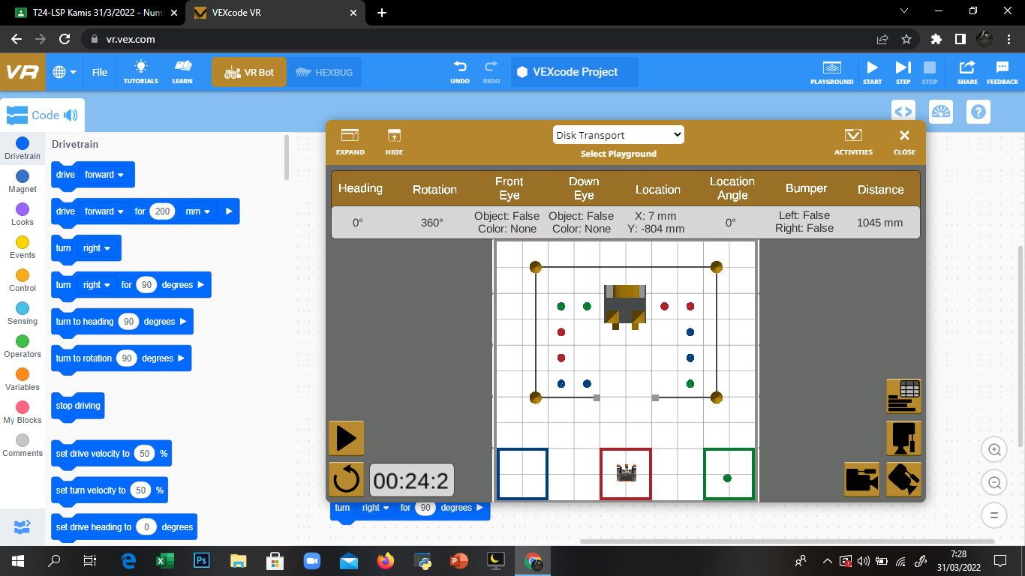

Code :

